**Improving Dam Failure Hazard Communication: Coupling Virtual Reality and Remote Sensing for Simulation Optimization**

## Hannah Spero1, Iker Vazquez-Lopez2, Kenny Miller3,and Rezvan Joshaghani2

**i. Abstract**

Dam failures occur worldwide and devastate downstream communities. Communicating the severity of these hazards is imperative. Two-dimensional (2D) dam failure hydraulic modeling furthers understanding of dam failure flood regimes but is limited in depicting complex multi-resolution dam failures' spatial and temporal changes. Therefore, this paper proposes the first open-source workflow for constructing earthen dam failures in a three-dimensional (3D) Virtual Reality (VR) environment. As a case study, we model the historic Teton Dam failure of 1976, based on a validated HEC-RAS 2D and GeoClaw 2D Teton Dam failure model. We visualize the hazard components associated with the duration of the historic dam breach by constructing a scaled VR environment; we focus on the parameterization of the historical dam breach using historical data and generating terrain from drone photogrammetry data using the Structure from Motion (SfM) technique. This study validates the VR environment on the Oculus Quest 2 VR Headset, evaluated by the criteria: immersion fidelity, movement, immersive soundscape, and agreement with historical data. Communication of dam failure hazards to non-specialist audiences such as legislators, K-12 students, or communities requires creativity. VR provides an environment for sharing knowledge, improving science literacy, and developing improved community resilience.

**1. INTRODUCTION**

As the U.S. dam population ages and the downstream population living below the dams increases, it has become progressively more important to communicate the threat of dam failure to those communities before a disaster. There are over 90,500 dams in the U.S. [1]. It is estimated that by 2030, an average of seven of ten dams in the United States will be ‘high hazard,’ meaning they will likely devastate human life and infrastructure in the downstream communities that lie below upon failure [2]. Additionally, dam failures have occurred in every state in the U.S. and often lead to fatalities and life safety consequences [3]. As dam failures threaten both human life and infrastructure and dam failures are predicted to increase in the frequency of occurrence, it is essential for the public to understand the threat and for researchers to communicate with citizens and industry professionals.

Numerical modeling techniques, such as 2D modeling of dam failure, are often used by professionals to provide critical information to dam owners and floodplain managers (flood wave arrival time, lateral extent, water surface elevation). However, 2D models also can provide a basis for developing 3D Virtual Reality (VR) environments. VR is a technology that simulates a fully immersive virtual environment in which the user feels physically present [4]. For purposes of this study, we use a head-mounted display (HMD), a standalone headset with a self-contained system within the device, to transport researchers and non-specialists alike to the Teton Dam environment.

As science progresses, sharing information constructively with the public does not always occur, especially concurrently. Therefore, this study improves community science literacy through immersion in a disaster simulation, as improved science literacy can improve citizen responses to hazards, evacuations, and overall community resilience. STEM literacy is critical for propelling society towards a more resilient future, yet facilitated collaboration with the public is currently lacking [5]. This study focuses on bridging that gap by creating an effective 3D communication tool. This tool can connect all stakeholders and redesign communication to be two-way in the face of natural disasters like dam failures.

***1.1 Related Works***

***1.1.1 New Technology and Advancements Allows for VR Communication Tool***

VR is a technological industry that has developed over the past decade to lead technological advancements for fields ranging from biomedical training to the sports industry. Recently technological advances in VR have allowed for inexpensive and portable VR, which creates opportunities for scientific visualization tools which can harness this new modality as a communication platform. Despite these advancements, VR application in the communication of natural hazards requires more in-depth research due to the low number of studies. In addition to that, no studies are investigating VR as a tool for communicating earthen dam failure hazards or historical dam disasters.

This study uses the newest VR head-mounted display (HMD), the Oculus Quest 2, to determine the potential widespread adoption of VR as a natural hazard and disaster communication tool. The portability of the Oculus Quest 2 (no cord attached to a computer) means increased accessibility to people of all abilities as well. Therefore, this study leverages the Oculus Quest 2 VR system, specialized for viewing and interacting with 3D data, as the communication medium.

Advancements in computational power allow the creation of complex VR environments, so determining the processing limitations of this powerful communication tool allows for a new understanding of 3D communication. This study aims to determine if the high-resolution topography (HRT) necessary to a realistic VR environment is too computationally and compiling intensive for a standalone HMD like the Oculus Quest 2. We also investigate if a high-resolution topography generated from remote sensing techniques (Structure from Motion - SfM) allows for improved terrain [6]. SfM is a newer method for generating high-resolution topographies but has not yet been integrated into VR research. SfM is a method that uses 2D images gathered by a UAV (Uncrewed Aerial Vehicle) to estimate 3D structures by stitching photos together into a highly detailed photogrammetric model [19]. We test our methodology to determine an efficient and preferable workflow to create a realistic simulation with HRT to generate a viable scientific communication tool for dam failure hazards.

***1.1.2 History of VR Modeling for Hazards, Disasters, and Communication***

VR has been used for community resilience research for hazards such as mining, fire, flooding, and earthquakes. However, a workflow with applicability for industry and academia alike has not been conceived for dam failure modeling. Previously, Virtual Reality has simulated specific mine operator hazards and situations (underground mine fire and explosion) for hazard awareness training, demonstrating applications to professional development [7]. Other VR environments can simulate mining roof fall hazard assessment and mitigation [8;9]. For urban fire research, Tucker et al. studied the effects of information and hazard on evacuee behavior in VR when in a burning building emergency [10]. This study demonstrated VR efficacy in inducing anxiety in evacuations and showed that providing targeted information decreased evacuation time [10]. Therefore, VR has applications ranging from a technical understanding of natural hazards and disasters to applications to the social science of disasters such as evacuation.

Another primary focus of VR research is achieving VR immersion or preventing dizziness for 3D disaster scenes, often called cybersickness [11]. In a riverine flooding VR model, Hu et al. investigated how to pair the left and right eye synchronicity, minimizing user dizziness or sickness [12;13]. VR also has uses in the earthquake simulation platform for simulating earthquakes which induced dizziness to enhance the panic earthquakes can cause to test VR environment realism [14].

To generate a realistic environment, this study uses previous research as a foundation, takes advantage of new VR technologies, and expands the current understanding of usage by using a new headset (Oculus Quest 2). In addition to that, this study shows how the pathways between the three spheres of industry, academia, and non-specialist citizens can be improved. This study uses previous research to generate a realistic environment, furthering the current understanding of usage by using an Oculus Quest 2 headset to improve the communication among industry, academia, and non-specialist citizens***.***

***1.2 Teton Dam Study Area, Case Study Selection Reasoning, & Available Data***

***1.2.1 Teton Dam Study Area***

The Teton Dam was located on the Teton River in Eastern Idaho on the Northeast edge of the Snake River Plain. Standing at 93 m tall and with 289,374,408 volume in the reservoir [15], it was the largest structural collapse in US history [16]. The Teton Dam failed on June 5th, 1976, and was one of the costliest dam failures in United States history – costing over an estimated $2.5 billion in damage [15]. The Teton Dam failure event also instigated agencies and groups that monitor dam safety, such as the Association of State Dam Safety Officials [16].

***1.2.2 Teton Dam Case Study Selection***

Generating a VR environment for validation requires 2D model comparison, historical data comparison, and significant input parameters. This study selected the historic Teton Dam failure as a case study because it is historically significant with widespread effect; it changed how dams were designed and monitored and has abundant data that is publicly accessible. Additionally, a concurrent study had created and validated two 2D hydraulic models of the dam failure allowing for 2D model comparison with this VR environment [20].

***1.2.3 Available Data***

Pertaining to data, when modeling or creating a VR environment, it is critical to have high-resolution topographic data and detailed disaster records. This study sourced two low-resolution terrains (30and 10) and generated terrain from raw geotagged drone photogrammetry data [17; 18]. Other available data included public historical archives containing abundant data with information like dam blueprints and breach geometry [15].

|  |  |
| --- | --- |
|  |  |

***Figure 1.*** *These schematics show the Teton Dam and were created from historical blueprints. The values are in NGVD 29 vertical datum. The Teton Dam crest height was 93 m in height, the length of the crest was 914 m, and the width of the crest was 11 m [15]. This dam stored a volume of 355,242,240 (Datum, NGVD 29) along the Teton River, only reaching* 289,374,408 *before failing [25].*

***1.3 Technological Hurdles in VR Game Creation***

Movements in the virtual space can help communicate complex processes, but the technical side of this endeavor is challenging. As this is a new field of research, this study also determines what elements are necessary to a dam failure VR environment to make it convincing and safe for users of all ability levels.

**2. STUDY OBJECTIVES**

Therefore, with current resources lacking the ability to identifying spatially and temporally changing features for researchers, and with the intersectionality of communicating dam failure, this project aims to address the following two key objectives with underlying questions:

1. Use VR to communicate earthen dam failures in the lens of community resilience
   1. What elements are necessary to a dam failure VR environment to make it convincing?
   2. How can we create a workflow for researchers and industry professionals alike to develop VR dam failure environments of their own?
   3. Are remote sensing techniques, such as SfM in VR environment creation viable for terrain generation?
2. Determine the visualization capabilities of the Oculus Quest 2 headset, the newest technology, and limitations for processing.

**3. METHODS**

Methods focus on creating a VR Teton Dam failure environment and demonstrate the workflow for researchers to use for their own applications. Through this workflow, the communication of dam failure hazards can be significantly improved and used to reach non-specialist audiences.

***3.1 Remote Sensing and High-Resolution Topographies***

The first step in this study was to generate a base terrain for the VR environment by processing drone photogrammetry data collected by the Bureau of Reclamation [18]. This high-resolution topography (HRT) output is critical to this study, as having a realistic terrain and texture in the VR environment allows users to immerse themselves fully. The topography [21] (TetonPhoto.topo) consisted of a 2.4 area at 0.30 *cm* resolution. Using AgiSoft PhotoScanTM software (*https://www.agisoft.com/*), a free and open-source application, over 10,000 photos were aligned based on their georeferenced location. Then, a dense point cloud was constructed with a 5-million-point density [22]. Through optimizing camera alignment and manually cutting out unnecessary or unconnected points, the dense point cloud was reduced to a 3-million-point density.

Photos depicting the river did not align well because of sunlight refraction on the day the drone data was collected. Water points were removed from the dense/point cloud and reconstructed by interpolation. Following generating the dense cloud, a mesh was built with a height field as surface type, and a DEM was output with a State Plane East FIPS 1101 coordinate system specified. An orthomosaic of the Teton Dam site was also exported for this study to generate the terrain texture file (colors of the VR environment). TetonPhoto.topo was exported iteratively to the Oculus Quest 2 HMD to test its performance solely on its onboard GPU. Iterative outputs included varying resolutions (0.5 cm, 1.0 cm, 1 m, 5m, 10m) and varying domain extents (3,048 m area to 305 m area). Thus, this study ensured we were using an image that was high-resolution while still performing at a high level (refresh rate). Despite size and resolution, all terrains were placed at the Teton Dam overlook, next to the left abutment, which hangs over Teton Canyon. Therefore, if a user were at the dam present day, they would stand in the same VR space and time travel to 1976.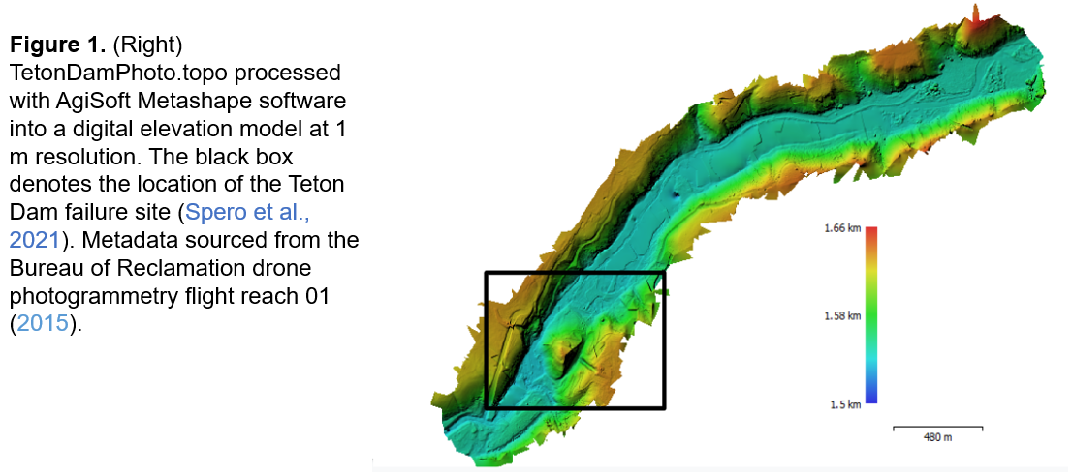

***3.2 Mathematical Model Development***

A 2D GeoClaw model and HEC-RAS model were used as a basis for the VR model construction [20]. GeoClaw ([*http://www.clawpack.org/geoclaw*](http://www.clawpack.org/geoclaw)) is a 2D hydraulic modeling software that uses the St. Venant equations to simulate a propagating flood wave over topography using adaptive mesh refinement. On the other hand, HEC-RAS ([*https://www.hec.usace.army.mil/software/hec-ras/*](https://www.hec.usace.army.mil/software/hec-ras/)) is a hydraulic modeling software developed by the U.S. Army Corps of Engineers (USACE). HEC-RAS is considered the industry standard for dam failure modeling and is accessible through a graphical user interface (GUI). These two 2D models were used as the basis for the dam failure breach geometry and flood wave interactions with topography, in addition to historical data where this study primarily used photos of the breach geometry. The GeoClaw and HEC-RAS models provided a basis for flood wave lateral extent fluctuations over time and water surface elevation (depth of wave), the key to the VR environment generating a validated 3D representation of the dam failure [20;23].

***3.3 VR Environment Development Workflow***

The VR environment development workflow generation consists of acquiring the terrain data, building fundamental structures, generating the animations, and exporting it to the Oculus Quest 2 headset. This workflow can be used for communicating various hazards by adapting the key elements and terrain data to the desired environment.

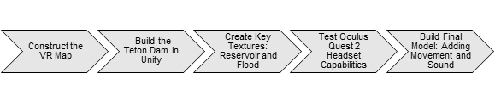

***Figure 2.*** *(Above). VR environment development workflow; left to right.*

***3.3.1 Construct the VR Map***

Designing the user experience first depends on the user placement and viewpoints. With the communication aspect of this study, we chose to place the user next to the left abutment of the Teton Dam, on the edge of the Teton Dam canyon. Therefore, they would be able to watch the historic dam breach. The left abutment overlook also was the location of a local radio show broadcast that warned citizens downstream of the dam to evacuate [24]. Therefore, this spot allowed for a unique soundscape implementation. First iteration VR environments included the two USGS digital elevation models (DEMs). Still, this data did not offer high enough resolution for realistic terrain, and therefore, this study considered other options. Consequently, this study used the photogrammetric terrain, TetonPhoto.topo, as the basis for the model. 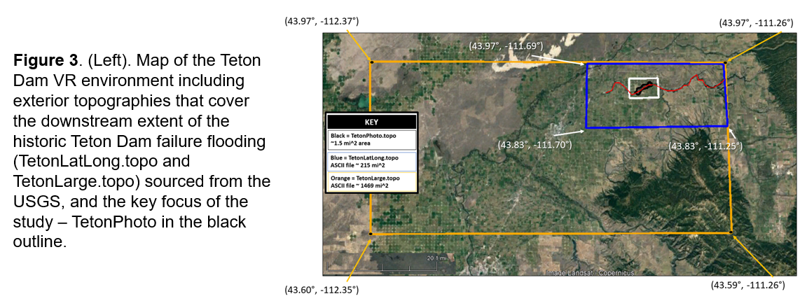

Methods for importing TetonPhoto.topo onto the Oculus Quest 2 involved testing different domain sizes and resolutions to balance the enhanced speed of interaction of the headset and the demanding computational requirements. We import the DEM as a ‘.obj’ file (standard geometry file format for 3D models) into the Unity ([*https://unity.com/*](https://unity.com/)) environment as the texture asset of the project. Unity has benefits and cross-platform capabilities, allowing our code and the VR environment to be adapted to multiple mixed reality platforms. Then, it is loaded into the center of the scene. A limitation of this method is that the Unity game development environment loads the model mesh without any imagery, and often due to orientation and scaling of the mesh, directly projecting the terrain texture onto the mesh does not match the model’s topography. Therefore, this study generated a shader that casts the surface onto the mesh, which provides sliders to adjust the texture dimensions and orientation. Using terrain features, such as dam spill track and dam remaining, we align the RGB terrain image with the topography.

***3.3.2 Build and Breach the Teton Dam***

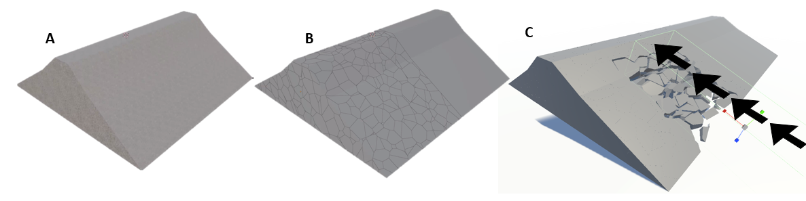

***Figure 4.***  *(A) Unfractured dam model created in Blender (B) Fractured dam model produced from (A) and Blender’s Cell Fracture tool (C) Collapsing of the fractured dam model in Unity. The black arrows denote the direction the trigger zone is moving in relation to the dam. The fractured pieces move in the opposite directions of the black arrows.*

The task of creating and rendering the dam breaking in virtual reality can be broken down into three main steps. Those steps being (1) creating a model of the Teton Dam, (2) fracturing that model into smaller pieces, and (3) creating a system that we can use to cause the dam to collapse. Steps 1 and 2 were conducted in Blender ([*https://www.blender.org/*](https://www.blender.org/)), a free, open-source 3D creation suite, and Step 3 occurs in Unity.

The first step was creating the dam using reference pictures of the Teton Dam and historic blueprints (Figure 5) as a base for the scale and size of the dam [15]. Then, this study used historical photos to generate an earthen texture for the dam’s appearance to provide a realistic look (Figure 4a).

For the second step, we fractured the dam using a built-in tool in Blender called Cell Fracture. To fracture the mesh of the dam into hundreds of smaller pieces, setting up this tool involved several computationally intensive scripts [21] (Figure 4b).

Further, for the third step, a script was created that runs during the simulation. In it, it would move a trigger zone towards the dam. Every piece inside the trigger zone is pulled down and out of its initial position. The trigger zone would then cause the other nearby parts to “break loose” and simulate the dam collapsing. We modeled the VR dam based on historical images and based the output flood wave on 2D hydraulic models (GeoClaw and HEC-RAS). Simulating the dam’s collapse is the most efficient method for modeling large-scale fracturing involving the many pieces the dam collapses into (Figure 4c).

***3.3.3 Create Key Textures: Reservoir and Flood***

Multiple studies on simulating water in diverse environments; however, the Oculus Quest 2 hardware limitations do not allow for high computational tasks. Therefore, we used low computational techniques, which improved the environment simulation performance at the cost of decreasing some of the quality. To represent the flood after the dam breach and keep the computational cost low, this study generated custom Unity shaders for the water flow and Unity’s cloth system to shape the hydraulic fall.

The water flow for the hydraulic fall and river use shaders to project two water textures on top of each other with different moving speeds in the same direction, which provides the water flowing sensation. On the contrary, the reservoir water does not have any flow and only shows small waves. In this case, instead of using one-directional movement, we used a sinusoidal texture movement. Since there is no data about the historical water height, we used the textures’ normal vectors to shift the planes’ vertex positions providing a more realistic water simulation.

For the hydraulic fall, we set a plane with a similar angle as the dam’s wall angle and applied the Unity’s cloth system, anchoring vertices at the sides of the plane (to fix them in place) and letting the rest of the vertices loose. The environment gravity pulls down the vertices and generates a convex shape mimicking the historical images.

To be closer to a realistic simulation, we set Unity particle systems that emulate water sprays at the bottom of the hydraulic fall and at the top of the dam, where the water passes through the breach. These particle systems were shaped and colored accordingly to simulate the water behavior at different locations. When the hydraulic fall collides with the river water, water textures are dispersed in a semi-spherical shape and brownish colored (representing the mix of water and dirt).

***3.3.4 Build Choices and Model Implementation on Oculus Quest 2 Headset***

We tested our application on Oculus Quest 2 VR headsets with 6GB of memory and a Qualcomm Snapdragon XR2 Platform as CPU. Oculus Quest 2 allows for both seated and stationary play and room-scale play. This study used player movement, both (i) allowing the user to move around the scene with the controllers in the static mode and (ii) letting the user walk around the scene in a 9 ft x 9 ft space with at least a 6.5 feet x 6.5 feet obstacle-free area. Therefore, this game used universal design criteria to enable accessibility to various users with differing ability levels.

Although these specifications are state of the art among commercial VR headsets, for a photorealistic rendering, it is weak. Therefore, to achieve the desired frame rate, we had to reduce the size of the terrain and switch to a shader-based water simulation rather than the particle-based one. However, we used a limited number of particles (170 per spray x 4 sprays= 680 particles) to add realism to the water when the Dam collapses. In creating the water shaders to simulate the flood, we were limited to unity core shader components as Oculus Quest 2 only supports the core shaders in the unity shader pipeline.

The soundscape consists of four overlain sounds: waterfall recording, Don Ellis radio broadcast from the Teton Dam overlook during the June 5th, 1976 dam failure, white water river recording, and lahar sound recording [24].

**4. RESULTS**

The two key objectives of this study are to (1) use VR to communicate earthen dam failures through a lens of community resilience in answering technical questions and (2) to determine the visualization capabilities of the Oculus Quest 2 headset, and its limitations for processing. This study indicates that VR is a technology that can be employed to simulate 3D dam failure.

***4.1 Results: Elements Necessary for VR Dam Failure Environment***

To answer the question, what elements are necessary to a dam failure VR environment to make it convincing, we iteratively assessed the model’s realism and improved it. To begin, our lightweight model contained a low-resolution terrain (5 m), no soundscape or user movement (they were confined to one spot although able to look around), two textures (reservoir and resultant flood), and one particle system. Even though the model performed well, the simulation was disconcerting without sound as the dam failed 2 minutes into it, but nothing oriented the user. VR environments require user autonomy environment interaction. Therefore, the lightweight model was used to support iterative model improvement to ensure rapid development and user autonomy.

The second model we generated used a similar approach as the first model but included an (i) higher resolution topography (1 m), (ii) user movement with two defined walking areas and cameras allowing multiple vantage points, and (iii) several small particle systems used at the interface of the two textures to model the hydraulic jump occurring as the dam failed. These elements allowed for a more realistic model, but non-specialists who entered the VR environment asked about a soundscape for orientation when they tried the model.

The third model-oriented users using a soundscape defined when they entered the closest proximity to the dam, and received feedback from users (at Boise State University’s Undergraduate Research Showcase) that the soundscape induced emotional reactions that aligned with a heightened perception of the dam failure and realism that they were physically at the dam (Figure 6).

Analysis comparing the coupled particle system and textures for depicting the hydraulic portion of the model revealed timing similarities in initial dam breach and flood wave arrival time downstream 0.5 mile and lateral extent (based on model scale and VR environment canyon water surface elevation of the initial wave) when compared to the GeoClaw 2D and HEC-RAS 2D hydraulic models. The canyon and water surface elevation scale aligned with the historical 50 ft value [15], as it reaches about ⅙ from the base of the canyon to the top of the flood wave, equating to 50 ft value (flood depth).

The final model (Figure 5) is housed in the open-source repository.

**\*\*\* IN WORD DOCX\*\*\***

Figure 6. (Above) Time series of the Teton Dam failure in the VR environment, where the number (1) denotes the VR model and (2) denotes historical photographs. (a) 11:50 AM before the dam failure, where the user can survey surroundings. (b) 11:56 AM as the Teton Dam begins to fail from the lower right abutment. (c) 11:57 AM, the Teton Dam fails as chunks of the dam fall into the canyon. The reservoir begins to flood the 300 ft deep canyon; the geometry of the dam failure portrays historical photos (1D) in 3D. (d) 11:58 AM progression of the dam failure continues. (e) 11:58 AM particle system depicts the hydraulic jump location between the laminar flowing reservoir into the turbulent flow of the canyon downstream of the dam. (f) 12:00 PM depicts the dam post-failure as the reservoir continues to empty the 234,600 acre-ft storage downstream in agreement with historical archives [15;27].

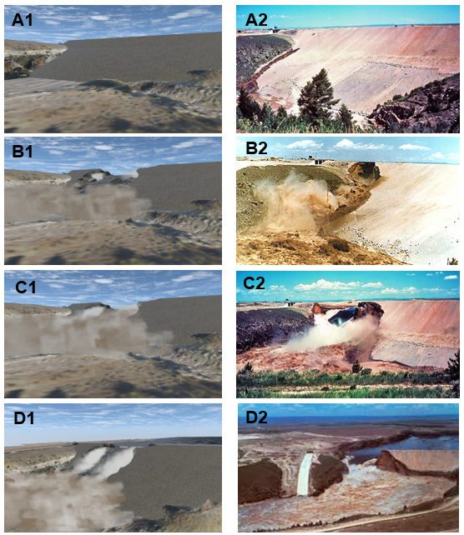

The stereoscopic graphics pop out at users, creating a unique experience. The system’s sensory stimuli are realistic, adding a soundscape, with sensory cues orienting users to the failing dam. The system's rendering display allows for an objective and measurable output simulation. Overall our workflow is low cost and demonstrates the capability of representing the historical Teton Dam failure event. The immersive soundscape, immersion fidelity, and agreement with historical data contribute to real-world visual stimuli of the 1976 Teton Dam failure and exemplify the opportunity this workflow can provide to others. Pertaining to the viability of SfM in creating VR terrain, the remote sensing technique of SfM is a viable option for terrain generation, from UAS flight to collect images to processing in open-source applications such as AgiSoft PhotoScan.

**5. Discussion**

We have several key goals as we continue our work. Specifically, we want to (i) investigate the application of our workflow to other historic earthen dam failures and (ii) build a STEM curriculum assessing VR as an educational tool. We plan to design and test collaborative experiences of non-specialists (K-12 students, legislators, and everyday citizens) in the Teton Dam environment for future work. This allows for a formal, large-scale user study of our application. Through feedback from users, we can improve the visualization and experience in simulation.

Interactions between state-of-the-art textures (reservoir and outflow dam breach) created by this study and other VR components show movement and field of work can apply to other historic dam failures, including Oroville Dam (California, U.S), Ka Loko Reservoir Dam (Hawaii, U.S.), and the Swift Dam (Montana, U.S.). Using the head-mounted displays (HMDs) and the SfM terrain provides a low-cost workflow accessible to researchers and industry professionals alike as a communication tool.

Through interaction with the Boise State University community, we find that VR can communicate earthen dam failure. In the lens of community resilience, presenting VR simulations can aid in understanding science literacy and prepare citizens. Future work involves collaboration with social scientists to test the usefulness of reaching non-specialists. For K-12 education, we plan to test if integrating HMDs into the STEM curriculum increases interest in fields, especially for students who are minorities or traditionally underrepresented in those respective fields. Students of all ability levels will visit these remote locations and benefit from the practical understanding.

For improving the existing VR simulation of the Teton Dam failure, we recommend a photo capture session at the Teton Dam site to improve the immediate topography under and around the users. Although our head tracking, fixed viewpoints, and positional audio allow for a realistic simulation, further enhancing the refresh rate of the images could allow for improved simulation. The SfM terrain provided from accurate metadata allowed for a scaled model and resemblance of the historic breach, which agrees with historic photos. However, even though we achieved a good alignment, there was a significant problem due to the remote sensing capture nature. Since the captured image was captured in a top view manner, canyon walls were not correctly captured. Therefore, pixels projected onto the walls appear stretched and are not correct. An advantage of our workflow is that other 2D dam failure models that exist already have a skeleton framework (flood wave progression, wave depth, and arrival time) for the application of our VR model workflow. Future work could also involve modeling dams that have not yet failed or been breached, communicating to legislators the threat that exists, and the funding necessary for older high-risk dams.

Altogether, the workflow outlined in this study and open-source repository allows for researchers and industry professionals alike to develop VR dam failures for other historic dam failures. The Teton Dam failure VR simulation demonstrates the efficacy of the Oculus Quest 2 headset and the simulation. For inaccessible areas and other disasters that might occur remotely, SfM would allow researchers to access these locations at a low cost and improve safety.

**References (formatted in the Word Docx and take up five pages)...so the document needs to be 20 pages flat. (we are right at 24 pages in the formatted document)**